Relaxation Exercises:

Calm Body Strategy

Muscle Relaxation

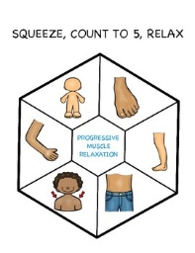

Do each exercise for 5 seconds

Scrunch up your face, then release.

Raise shoulder to your ears, release.

Make a muscle in arms, release.

Make a fist, release.

Pretend a ball is going to hit your belly, release

Squeeze your legs together, release.

Scrunch up your toes, release.

Relaxation Strategy

Blowfish Breathing

Breathe in through your nose. Puff out your cheeks like a blowfish. Count to 5 as you breathe out of your mouth and release the air from your cheeks

